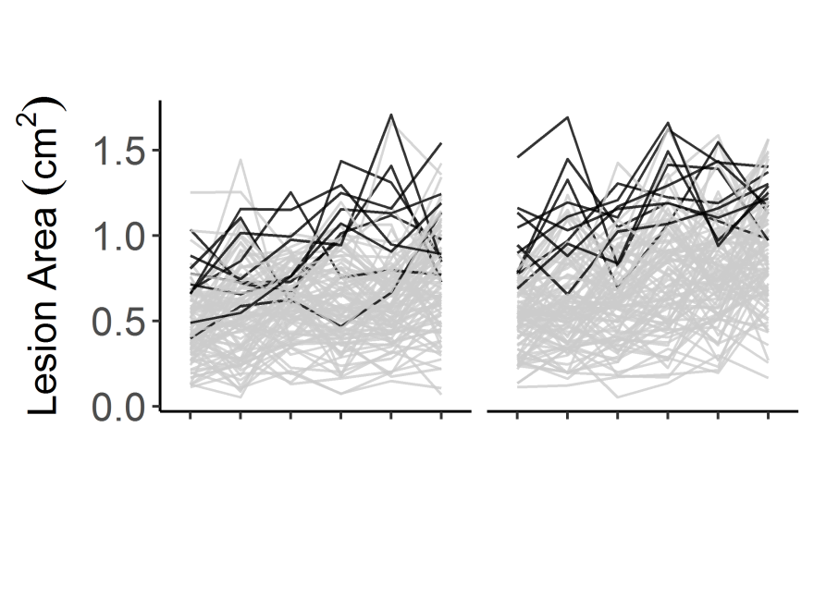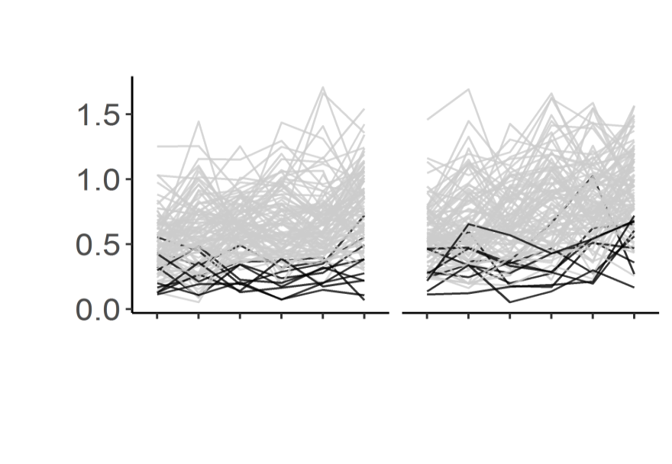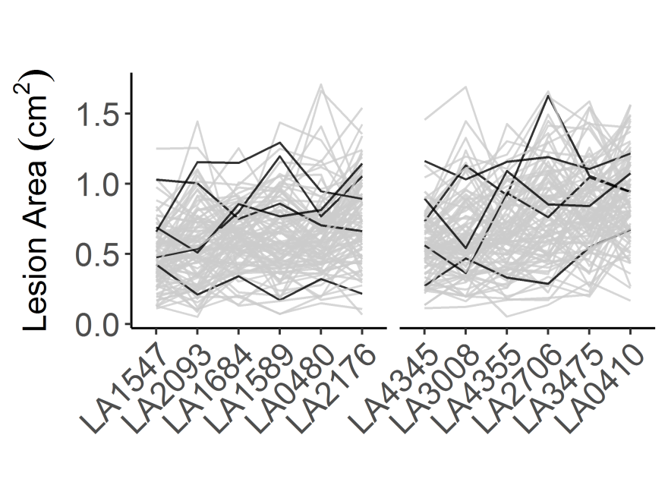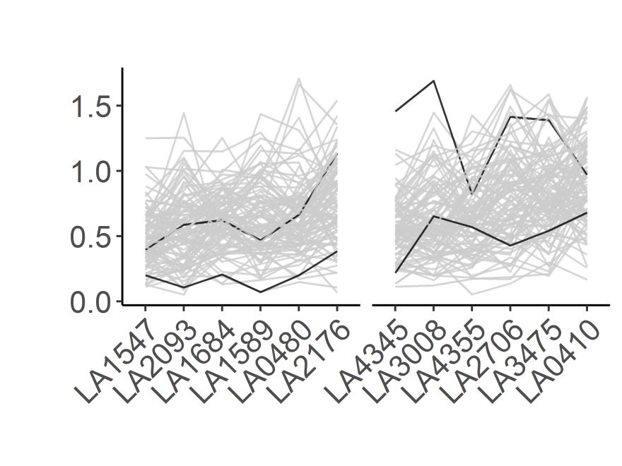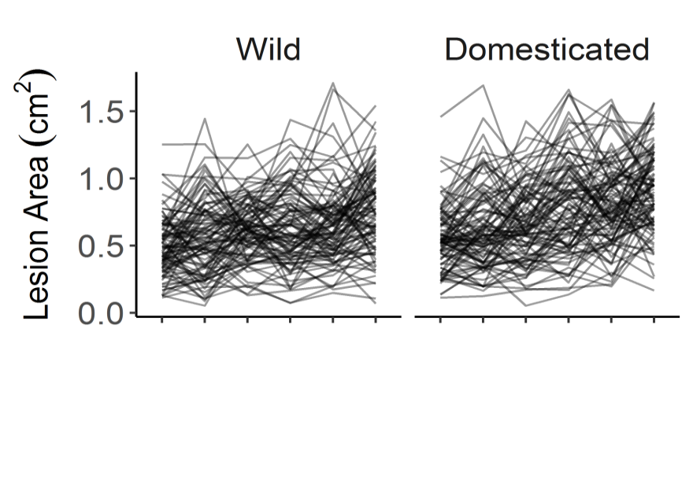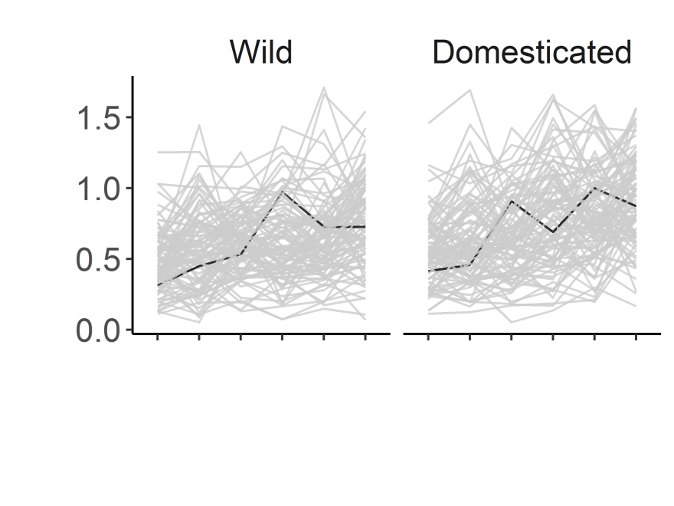

**c**

**d**

**e**

**f**

**g**

**h**

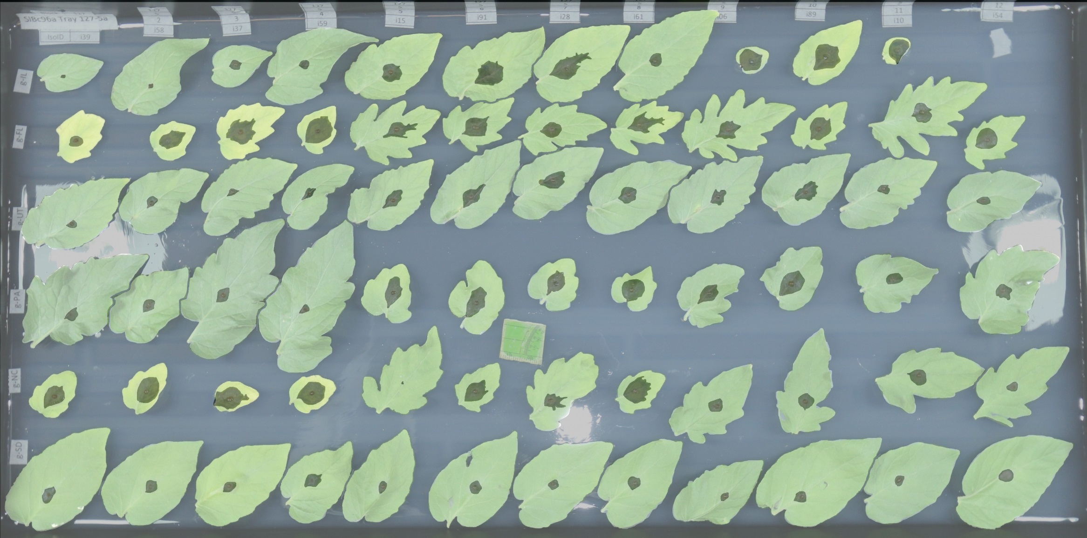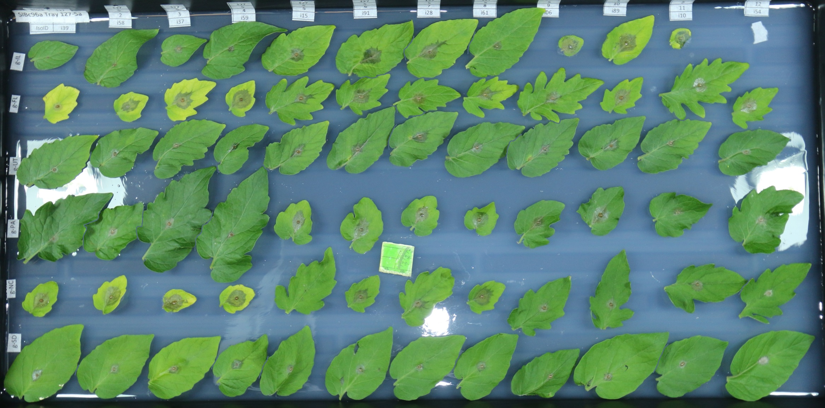

**a**

**b**

**Figure 1. *Botrytis cinerea* x tomato diversity in detached leaf assay and digital image analysis.** a) Individual tomato leaflets of 6 *S. lycopersicum* genotypes and 6 *S. pimpinellifolium* genotypes are in randomized rows, spore droplets of individual *B. cinerea* isolates are in randomized columns. Digital images are collected 72 hours post inoculation. Single droplets of 40 *B. cinerea* spores are infected on randomized leaflets using randomized isolates, and digital images are taken 72 hours post inoculation.

b) Digital masking of leaf and lesion is followed by automated measurement of area for each lesion.

c-h) Variation in lesion size resulting of the interaction of *B. cinerea* and diverse tomato genotypes.

c) Average lesion size of single *B. cinerea* isolates (line traces) across tomato host genotypes grouped by domestication status.

d) Highlight of the common reference *B. cinerea* isolate B05.10.

e) Highlight of the ten highest-virulence isolates, as estimated by mean virulence across all tomato genotypes.

f) Highlight of the ten most saprophytic, or low virulence, isolates, as estimated by mean virulence across all genotypes.

g) Highlight of the five isolates collected from tomato tissue.

h) Highlight of the two isolates with significant domestication sensitivity.

C:\Users\nesoltis\Documents\Projects\BcSolGWAS\paper\plots\FigR2\FigR2_beanplot_nogrid.tiff

**Figure 2. Distribution of tomato genotype susceptibility toinfection with 97 genetically diverse *B. cinerea* isolates.**

Violin plots show the distribution of lesion size caused by *B. cinerea* isolates on each tomato host genotype. Individual points are mean lesion size for each of the 97 different isolate-host pairs. The boxes show the 75th percentile distribution, and the horizontal line shows the mean resistance of the specific host genotype. The tomato genotypes are grouped based on their status as wild or domesticated germplasm.

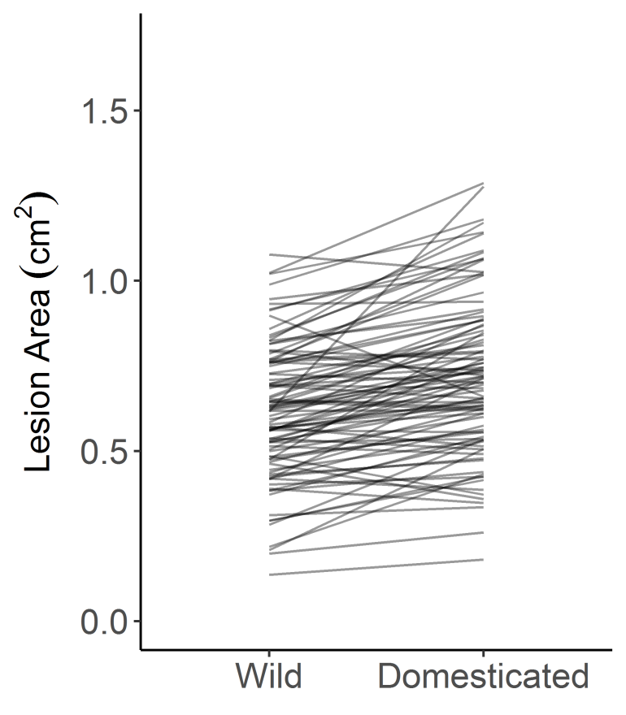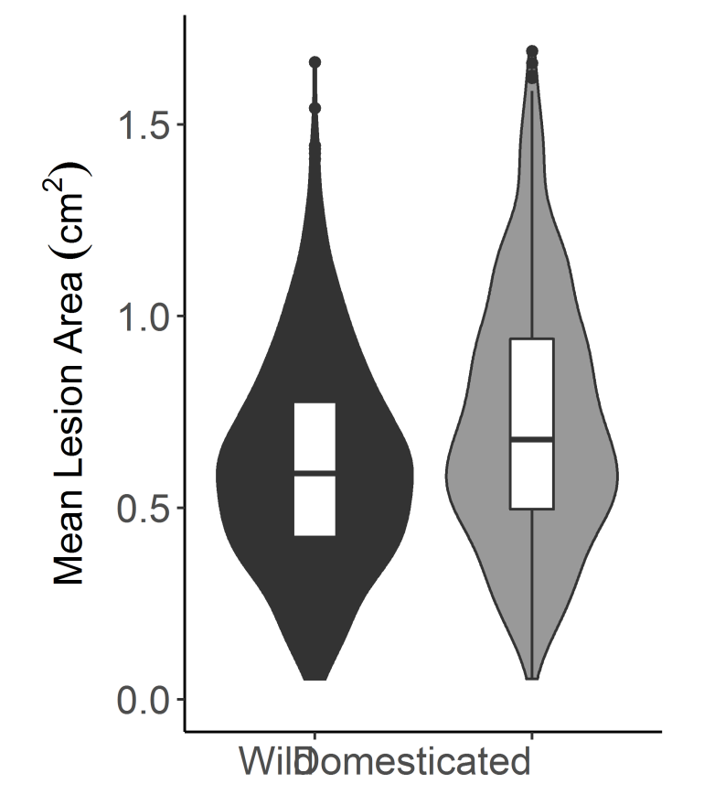

**Figure 3. Distribution of *B. cinerea* virulence by tomato domestication status**.

The violin plots show the mean virulence of each *B. cinerea* isolate on the tomato genotypes, grouped as wild or domesticated germplasm. The domestication effect on lesion size is significant (Table 1 ANOVA, p=0.0006). The interaction plot between the two violin plots connects the average lesion size of a single *B. cinerea* isolate between the wild and domesticated germplasm.

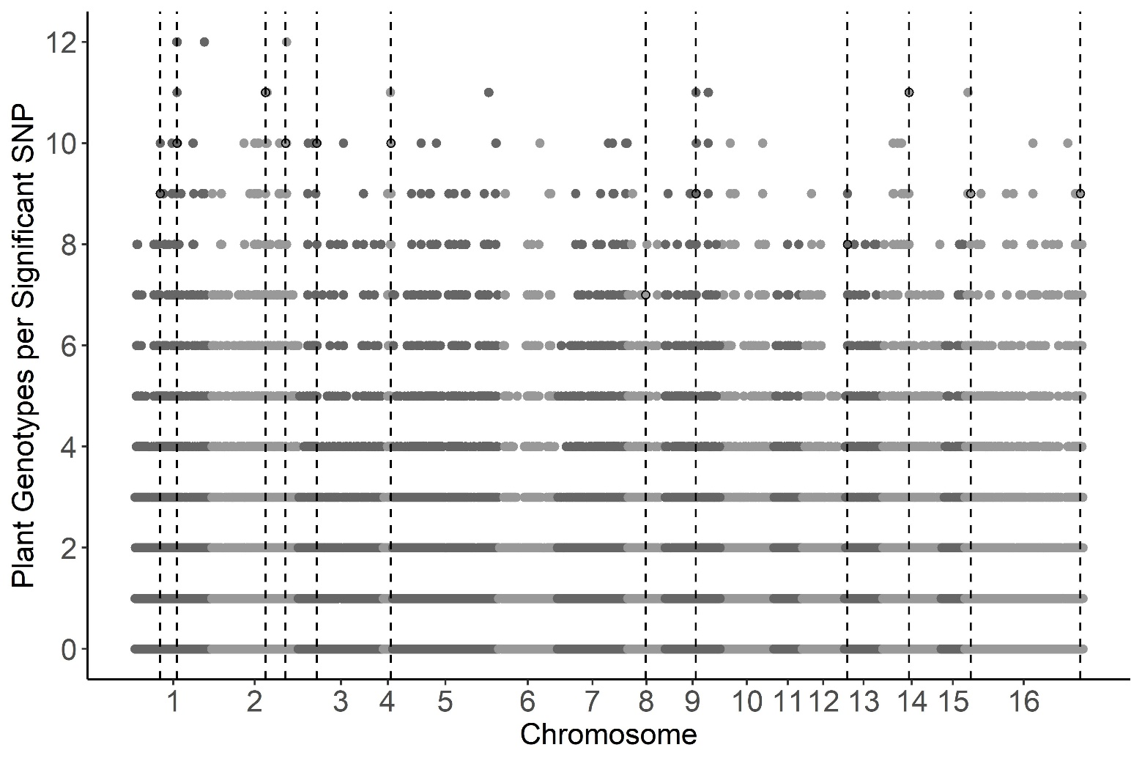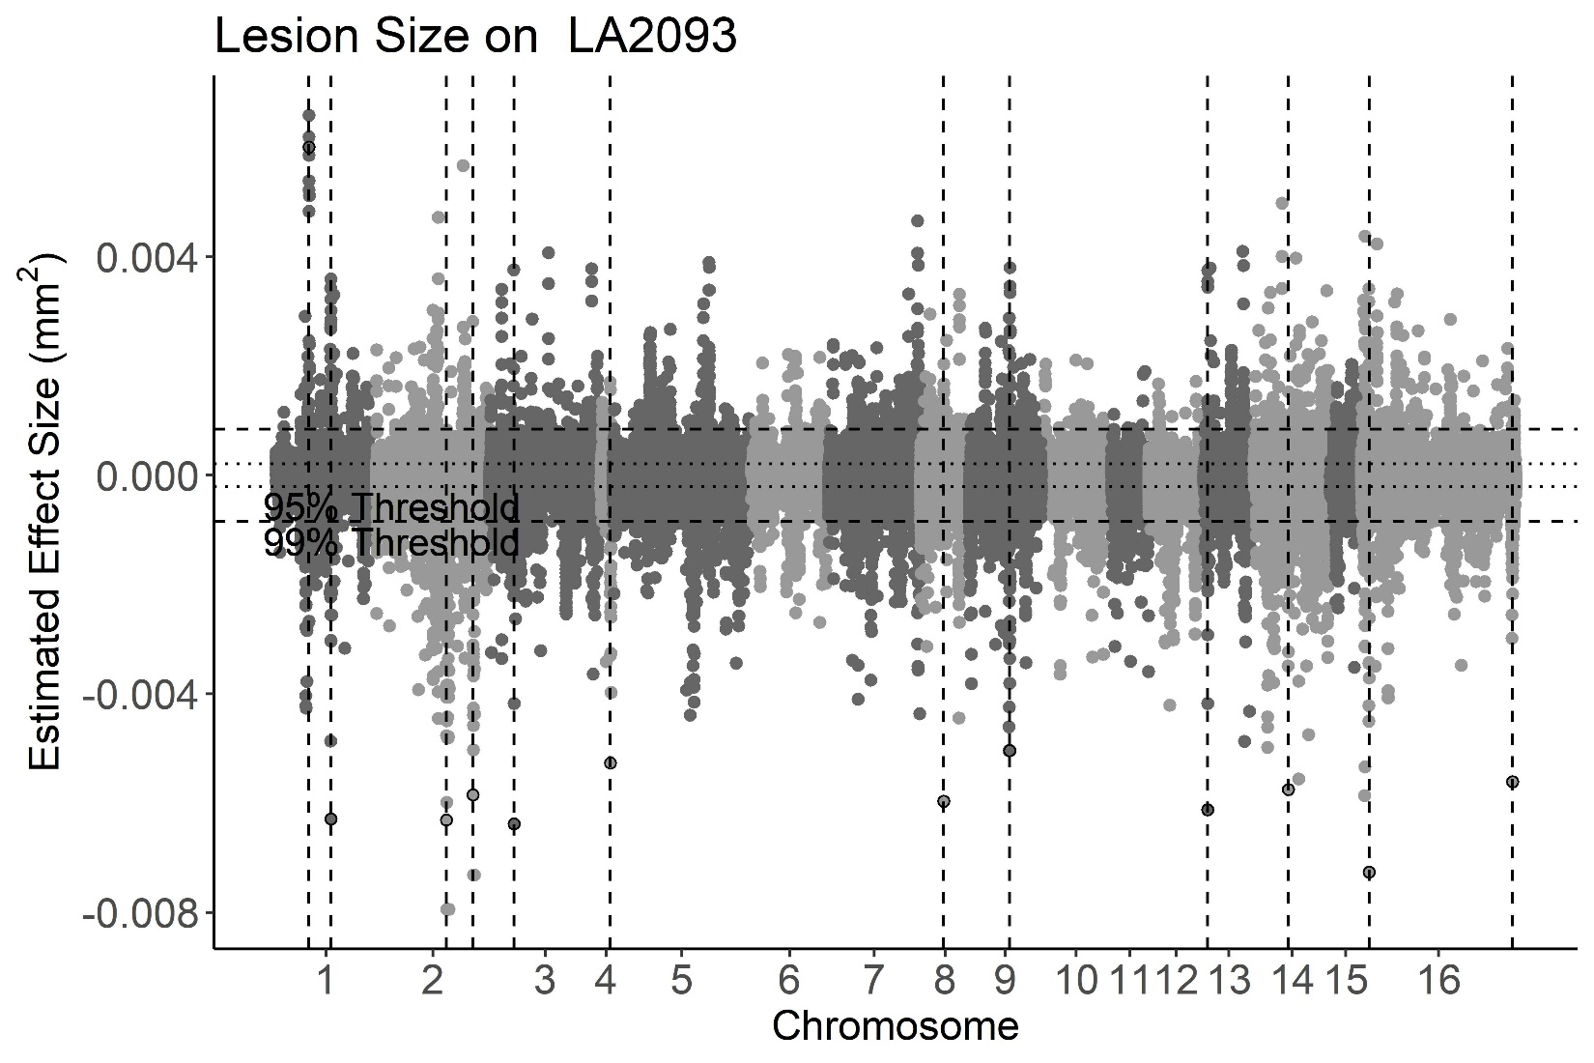

**a**

**b**

**Figure 4. GWA of *B. cinerea* lesion size on individual tomato genotypes.**

*Botrytis cinerea* chromosomes are differentiated by shading, alternating light and dark grey.

a) Manhattan plot of estimated SNP effect sizes from bigRR for *B. cinerea* lesion size using a single tomato accession, LA2093. Permutation-derived thresholds are shown in horizontal dashed lines.

b) The number of tomato accessions for which a *B. cinerea* SNP was significantly linked to lesion development by bigRR using the 99% permutation threshold. Frequency is number of phenotypes in which the SNP exceeds the threshold. Vertical dotted lines identify regions with overlap between the top 100 large-effect SNPs for LA2093 and significance across the majority (≥6) of tomato genotypes tested.

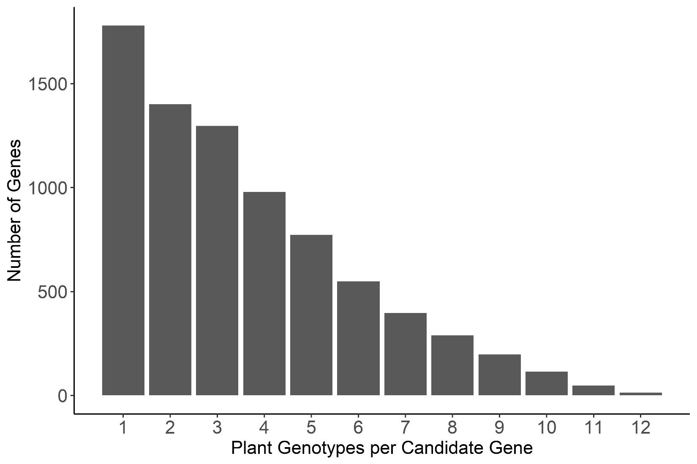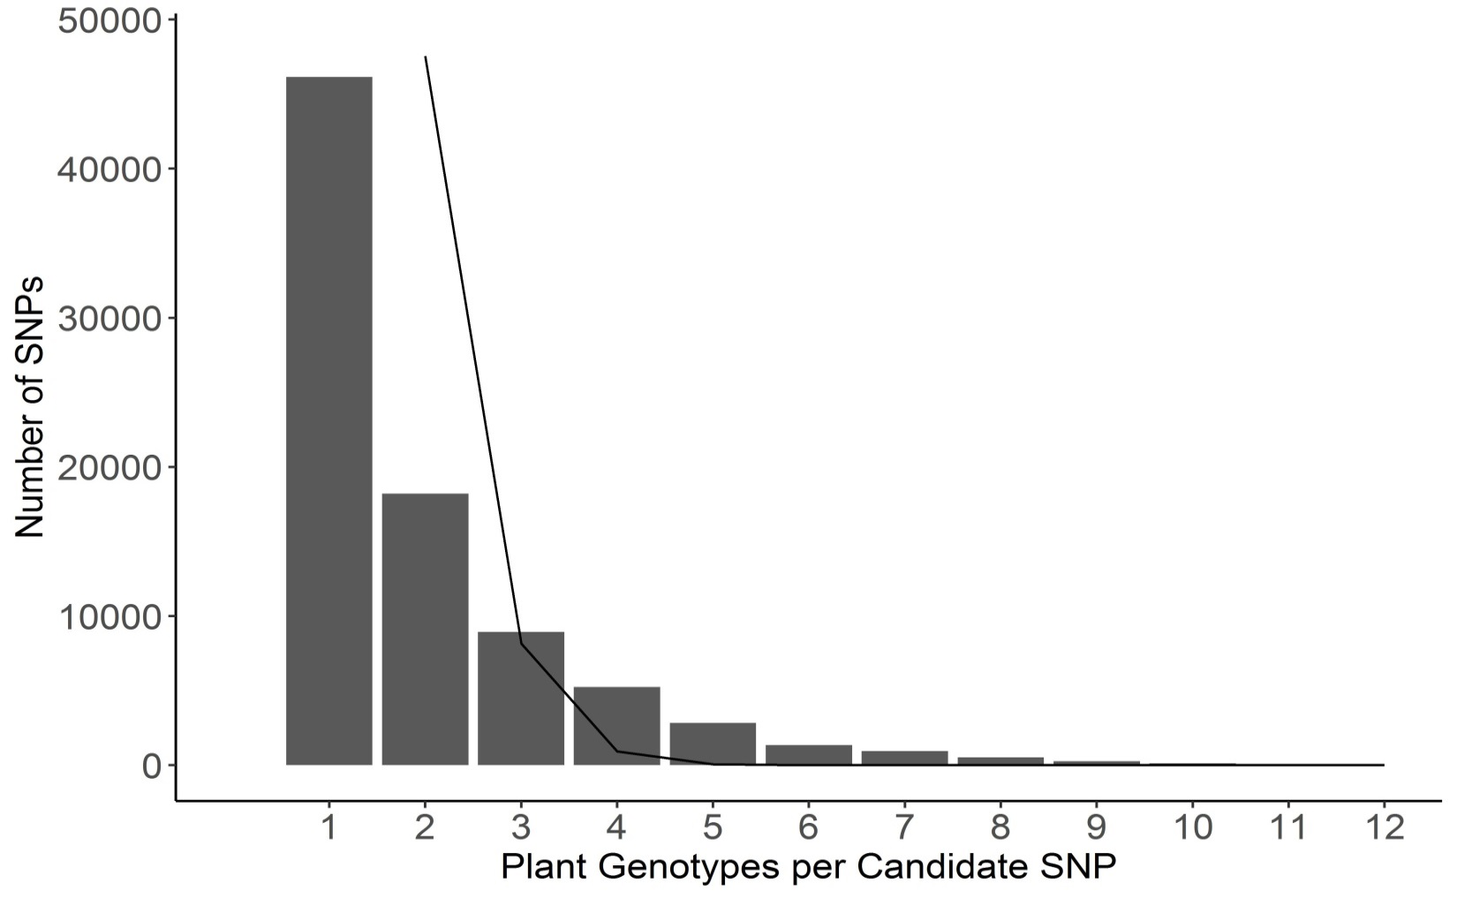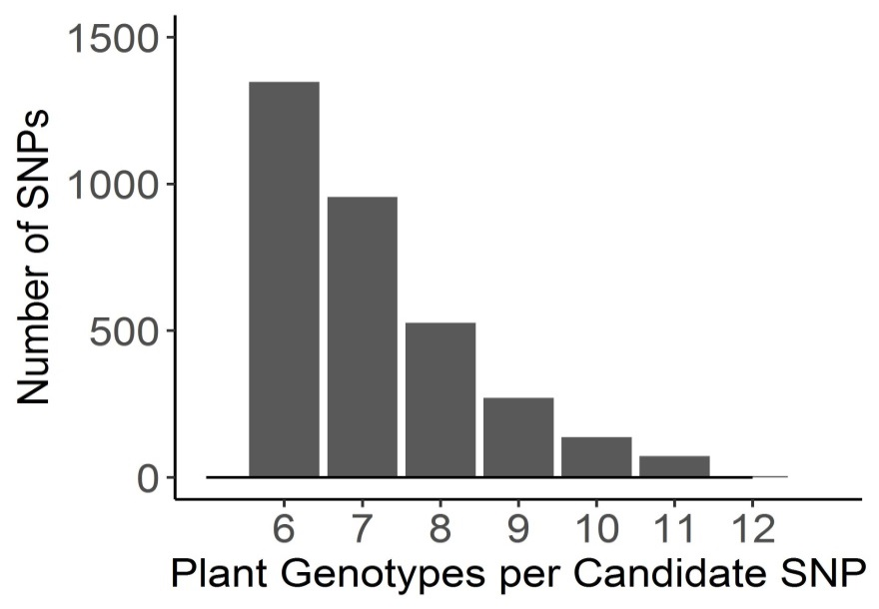

**a**

**b**

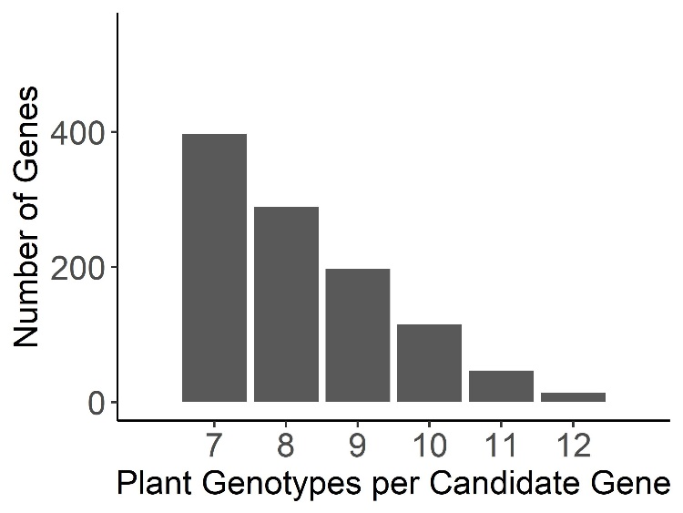

**Figure 5. Frequency of overlap in *B. cinerea* GWA significance across tomato accessions.**

a) The frequency with which the *B. cinerea* SNPs significantly associate with lesion size on the 12 tomato accessions using bigRR and the 99% permutation threshold. The black line indicates the expected frequency of random overlap, given the number of significant SNPs per plant genotype and size of total SNP set. The inset zooms in on the distribution for overlapping SNPs above 6 plant genotypes for easier visualization. There were no SNPs expected to overlap by random chance in the inset.

b) The frequency with which *B. cinerea* genes significantly associated with lesion size on the 12 tomato accessions. Genes were called as significant if there was one significant SNP called at the 99% permutation threshold within the gene body, or within 2kb of the gene body.

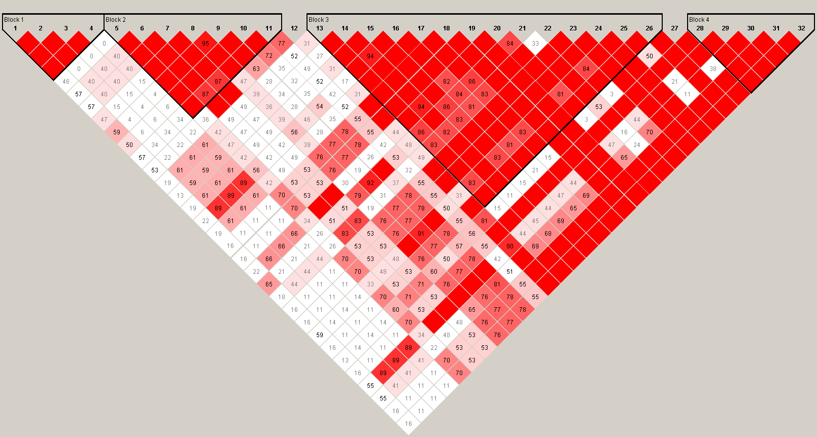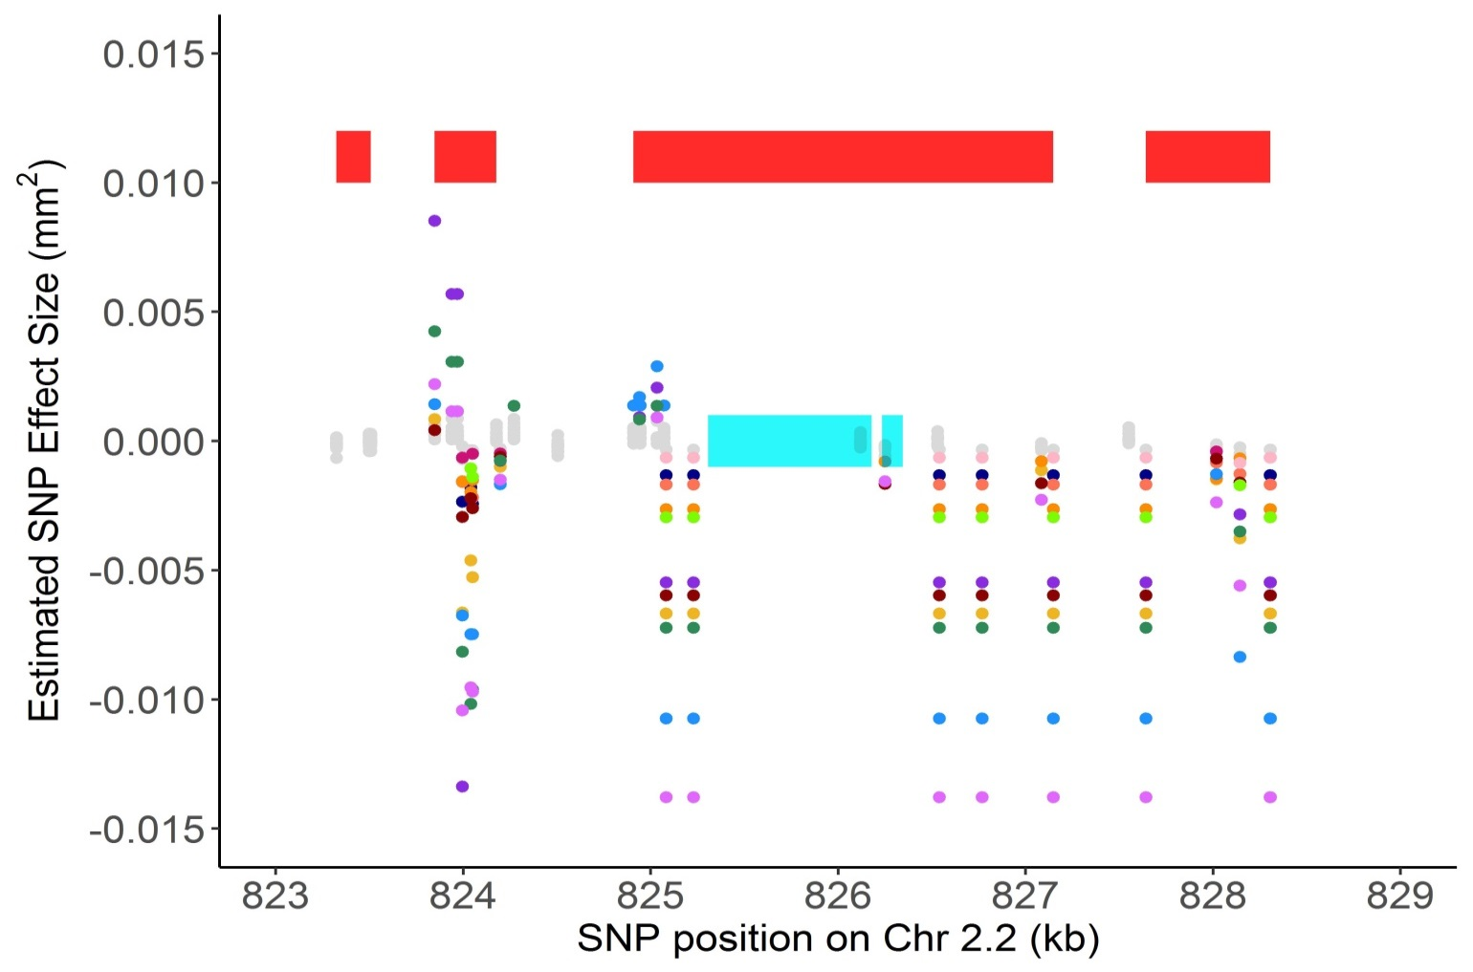

Block 1

Block 2

Block 3

Block 4

**a**

**b**

**Figure 6. Host specificity of significant SNPs linked to the gene BcT4\_6001 (Bcin14g00870).**

a) SNPs with effects estimates above the 99% permutation threshold are colored by trait (plant phenotype in which the effect was estimated). BcT4\_6001 (Bcin14g00870) is a pectinesterase gene linked to at least one significant SNP on all 12 of the tested tomato accessions by bigRR. The annotated exons are depicted as turquoise rectangles, with the start codon marked with an arrow indicating the direction of transcription. Red rectangles indicate corresponding linkage disequilibrium blocks from Figure 6b.

b) Linkage disequilibrium plot, including all pairwise comparisons of SNPs in the 2kb region surrounding Bcin14g00870. The color scheme for each SNP pair is D'/LOD: white if LOD <2 and D’ <1, bright red for LOD ≥2 and D’=1, intermediate shades for LOD≥2 and D’<1. The number within each square represents the D’ value for each pairwise comparison if <1.

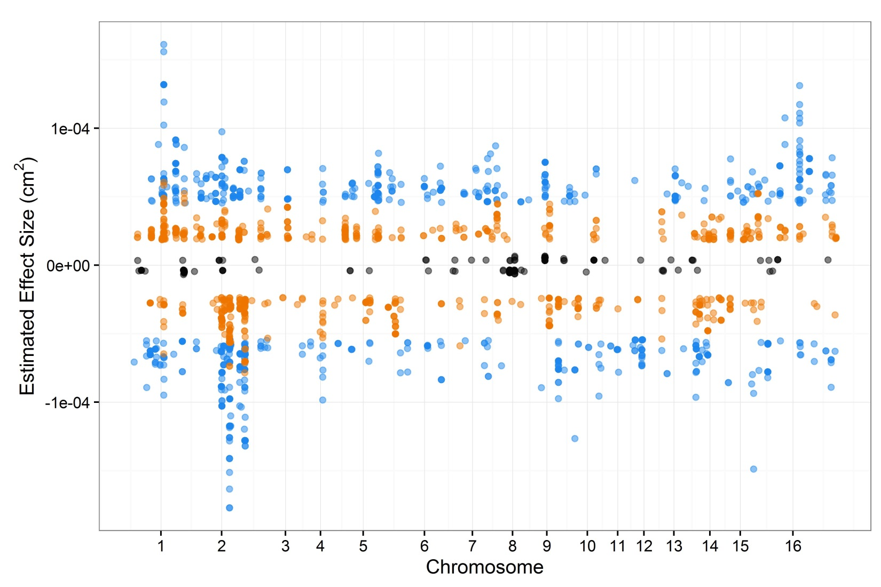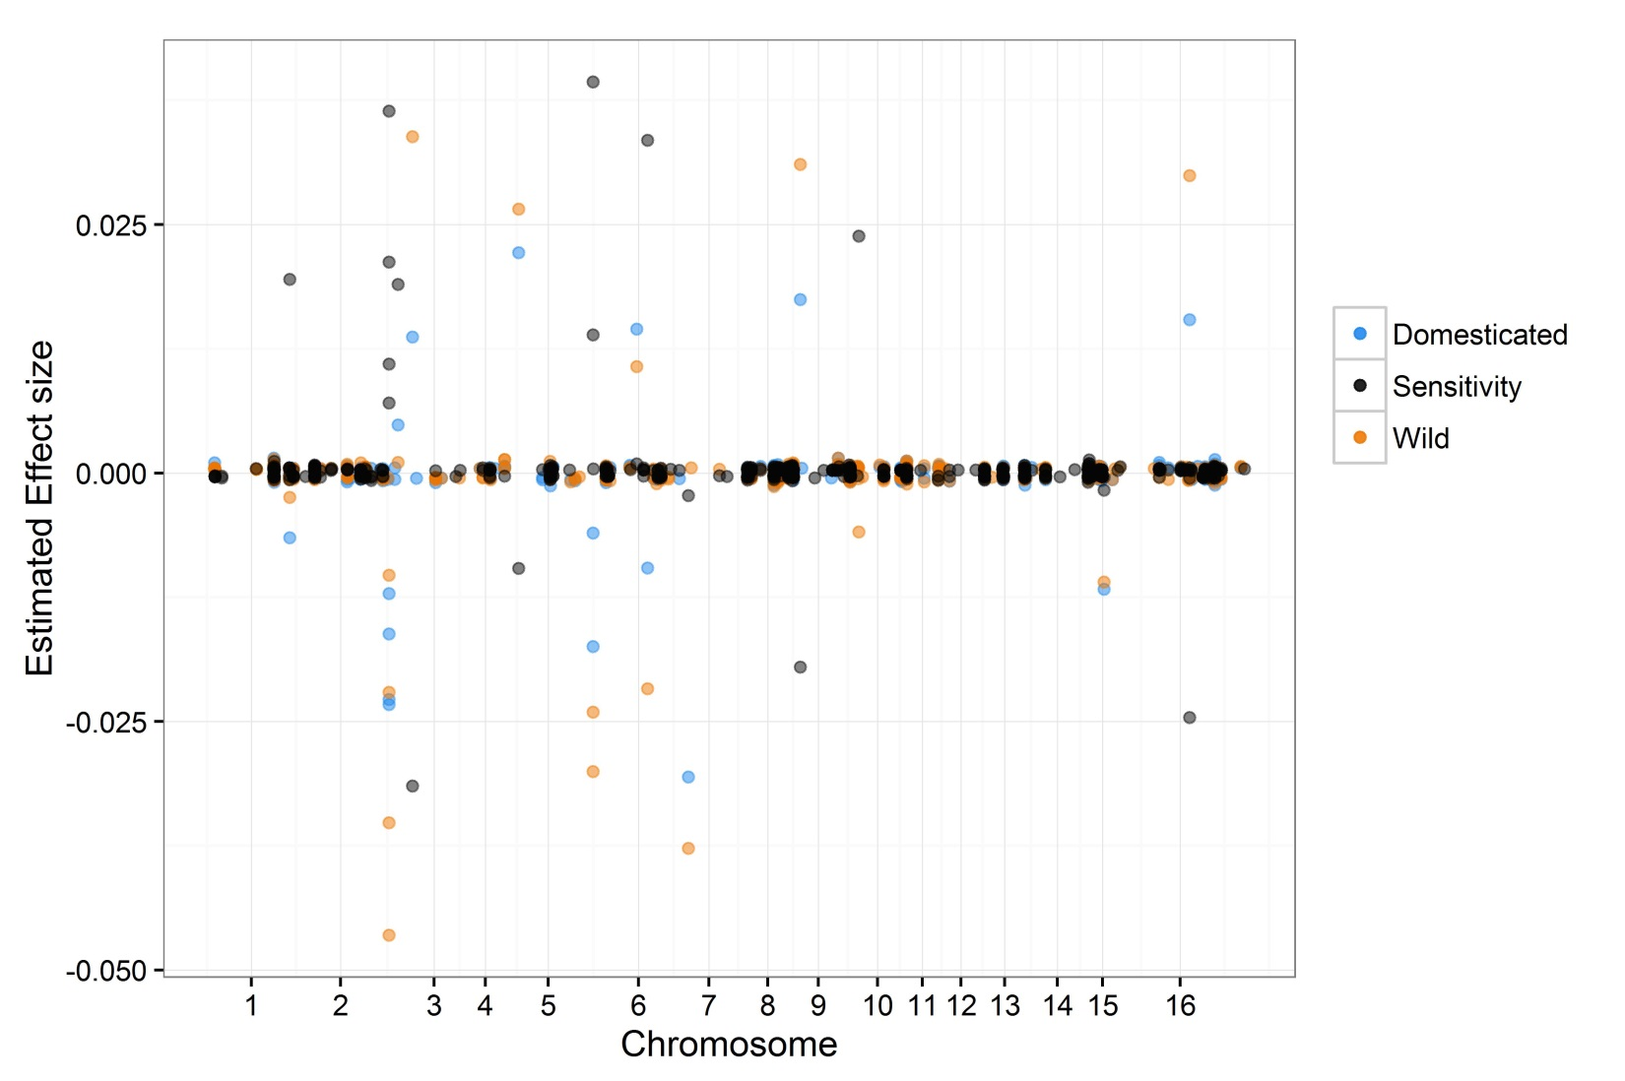

0.01

-0.01

0

(mm2)

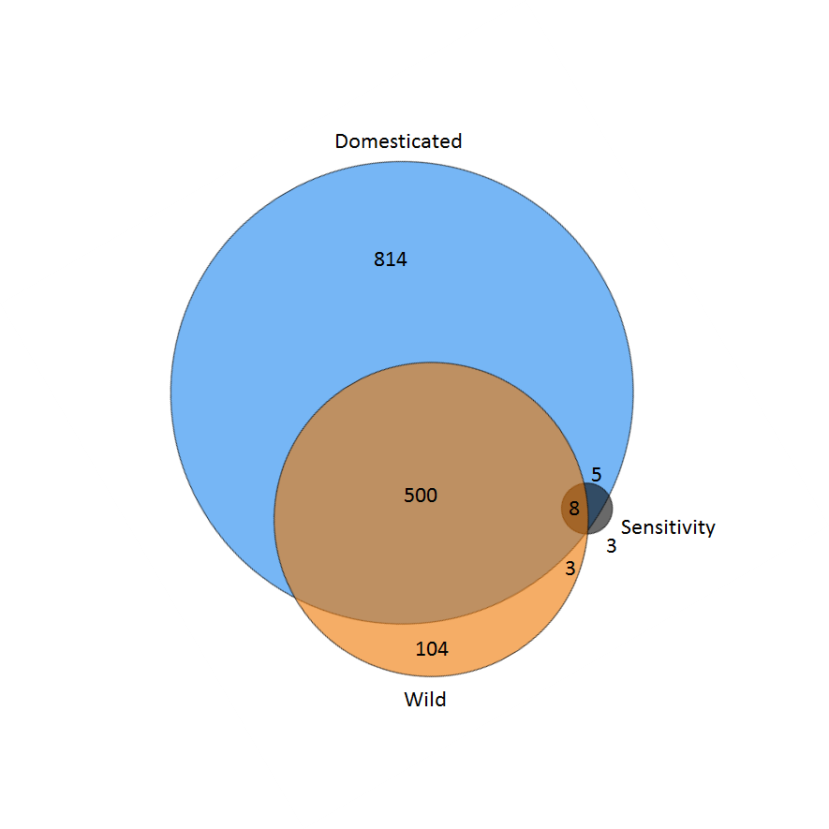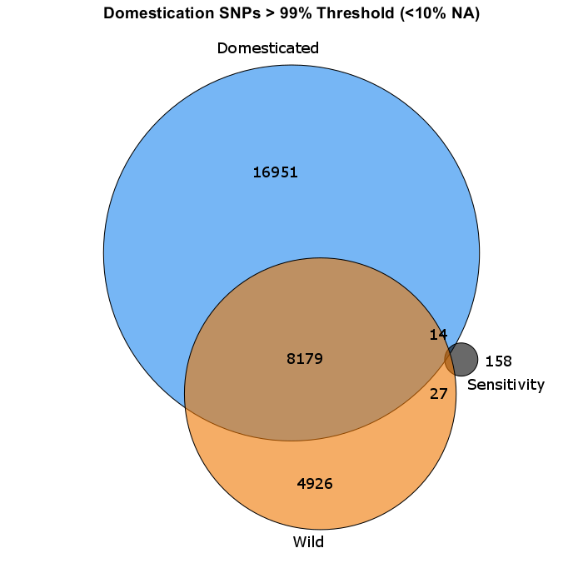

**a**

**b**

**c**

**Figure 7. GWA analysis of domestication sensitivity in *B. cinerea*.**

Domestication sensitivity of each isolate was estimated as the difference between the average virulence on the wild and domesticated tomato germplasm. This was then utilized for GWA mapping by bigRR.

a) The top 1000 SNPs that significantly affect lesion size across domesticated tomato, wild tomato or domestication sensitivity are shown. Significance is called as crossing the 99% permutation threshold.

b) Venn diagram of overlapping SNPs identified as crossing the 99% permutation threshold for each trait.

c) Venn diagram of overlapping genes identified as crossing the 99% permutation threshold for each trait. Genes were called as significant if there was one significant SNP within the gene body or within 2kb of the gene body.